 COSC 3380
Name: ______________ Seat # ___
Project 2: Relational – How; Implementation - SQL
(100 points)
(Due date found in the COSC 3380 Detailed Syllabus!)

Definition: “Project 1 with Line Numbers for ERD Modeling.doc” contains the “Requirements”. The “Requirements” cannot be changed without prior Client approval. This means that everything you place on these pages, such as templates for Es, Rs, and As cannot modify the “Requirements”. Not one line, not one word, not one character. You just annotate the “Requirements”. Client just wants to see the annotations over the familiar looking “Requirements” (No summaries in between lines).

A. (35 points) The Client has supplied the following data. Use SQL to insert these data in the Oracle DBMS database created in Project 1.

PLEASE NOTE that these tables might be different than the TABLES/RELATIONS you have obtained at the end of Project 1. In order to use these 9 TABLES/RELATIONS then you have to modify your ERD Textual Analysis (WORD only changes for Es, Rs, and As), your ERD DIAGRAM MODEL, your RELATIONal MODEL (Project 1 Step 1.b), your normalization steps (Project 1 Steps 1.c, 1.d), your revised ERD DIAGRAM MODEL (Project 1 Step 1.e) – “blue print”.

Your Project 2 using these 9 given TABLES/RELATIONS “house” will not be accepted unless your “blue print” is modified.

Customer
CustomerID, CustomerName, CustomerAddress, CustomerCity, CustomerState, CustomerPostalCode, CustomerEmail, CustomerUserName, CustomerPassword
1, 'Contemporary Casuals', '1355 S Hines Blvd', 'Gainesville', 'FL', '32601-2871'
2, 'Value Furnitures', '15145 S.W. 17th St.', 'Plano', 'TX', '75094-7734'
3, 'Home Furnishings', '1900 Allard Ave', 'Albany', 'NY', '12209-1125', ‘homefurnishings?@gmail.com’, ‘CUSTOMER1’, ‘CUSTOMER1#’
4, 'Eastern Furniture', '1925 Beltline Rd.', 'Carteret', 'NJ', '07008-3188'
5, 'Impressions', '5585 Westcott Ct.', 'Sacramento', 'CA', '94206-4056'
6, 'Furniture Gallery', '325 Flatiron Dr.', 'Boulder', 'CO', '80514-4432'
7, 'New Furniture', 'Palace Ave', 'Farmington', 'NM', ''
8, 'Dunkins Furniture', '7700 Main St', 'Syracuse', 'NY', '31590'
9, 'A Carpet', '434 Abe Dr', 'Rome', 'NY', '13440'
12, 'Flanigan Furniture', 'Snow Flake Rd', 'Ft Walton Beach', 'FL', '32548'
13, 'Ikards', '1011 S. Main St', 'Las Cruces', 'NM', '88001'
14, 'Wild Bills', 'Four Horse Rd', 'Oak Brook', 'Il', '60522'
15, 'Janet's Collection', 'Janet Lane', 'Virginia Beach', 'VA', '10012'
16, 'ABC Furniture Co.', '152 Geramino Drive', 'Rome', 'NY', '13440'
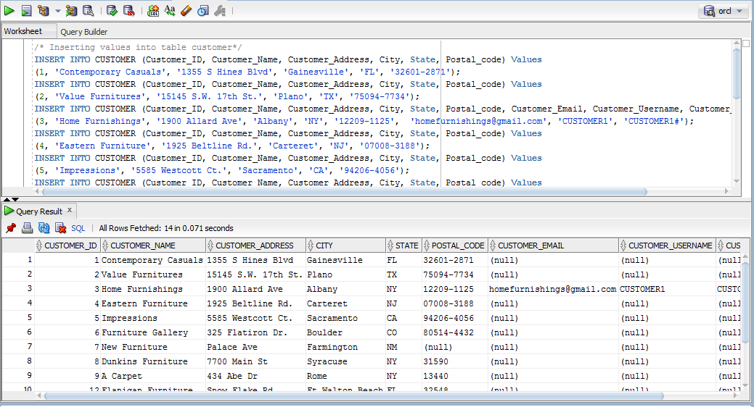
Salesperson
SalespersonID, SalespersonName, SalespersonPhone, SalespersonEmail, SalespersonUserName, SalespersonPassword,TerritoryID
1, 'Doug Henny', '8134445555', 'salesperson?@gmail.com', ‘SALESPERSON’, ‘SALESPERSON#’,1
2, 'Robert Lewis', '8139264006', '', '', '', 2
3, 'William Strong', '5053821212', '', '', '', 3
4, 'Julie Dawson', '4355346677', '', '', '', 4
5, 'Jacob Winslow', '2238973498', '', '', '', 5
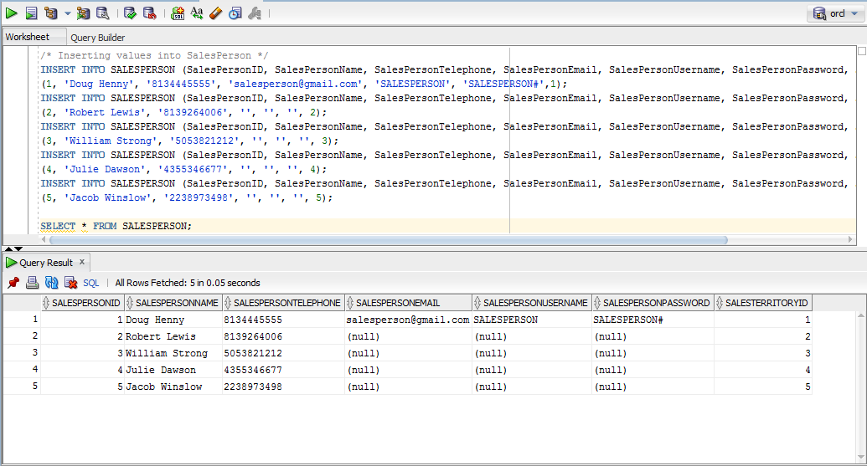

Territory
TerritoryID, TerritoryName
1, 'SouthEast'
2, 'SouthWest'
3, 'NorthEast'
4, 'NorthWest'
5, 'Central'

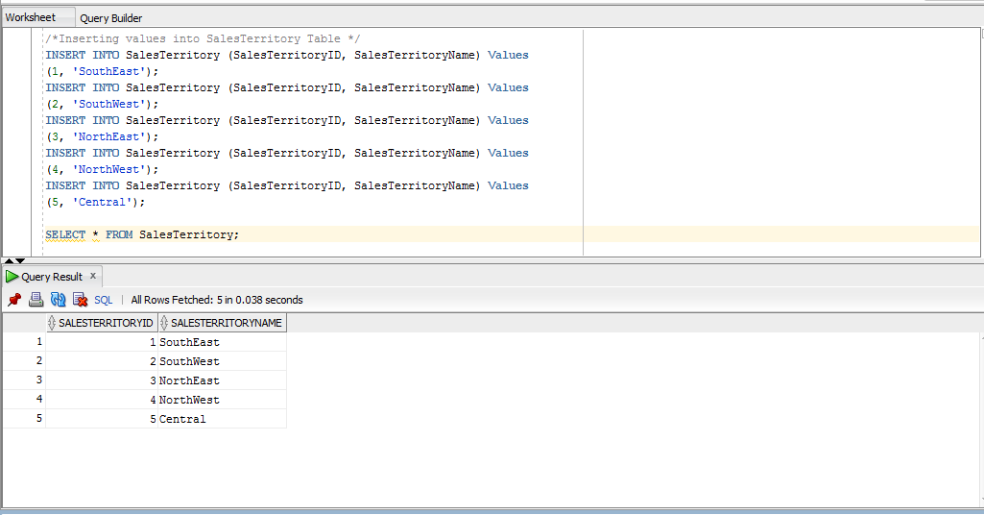
DoesBusinessIn
CustomerID, TerritoryID
1, 1
2, 2
3, 3
4, 4
5, 5
6, 1
7, 2
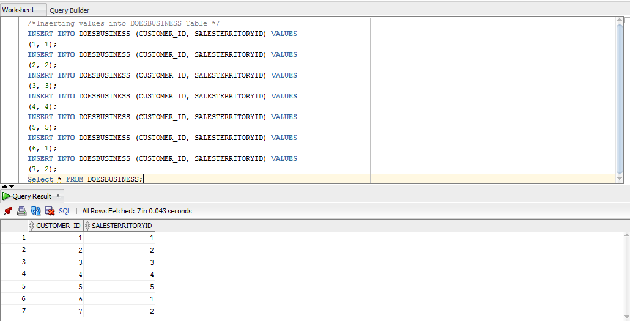
Product
ProductID, ProductName, ProductFinish, ProductStandardPrice, ProductLineID, Photo
1, 'End Table', 'Cherry', 175, 1, table.jpg
2, 'Coffee Table', 'Natural Ash', 200, 2
3, 'Computer Desk', 'Natural Ash', 375, 2
4, 'Entertainment Center', 'Natural Maple', 650, 3
5, 'Writers Desk', 'Cherry', 325, 1
6, '8-Drawer Desk', 'White Ash', 750, 2
7, 'Dining Table', 'Natural Ash', 800, 2
8, 'Computer Desk', 'Walnut', 250, 3

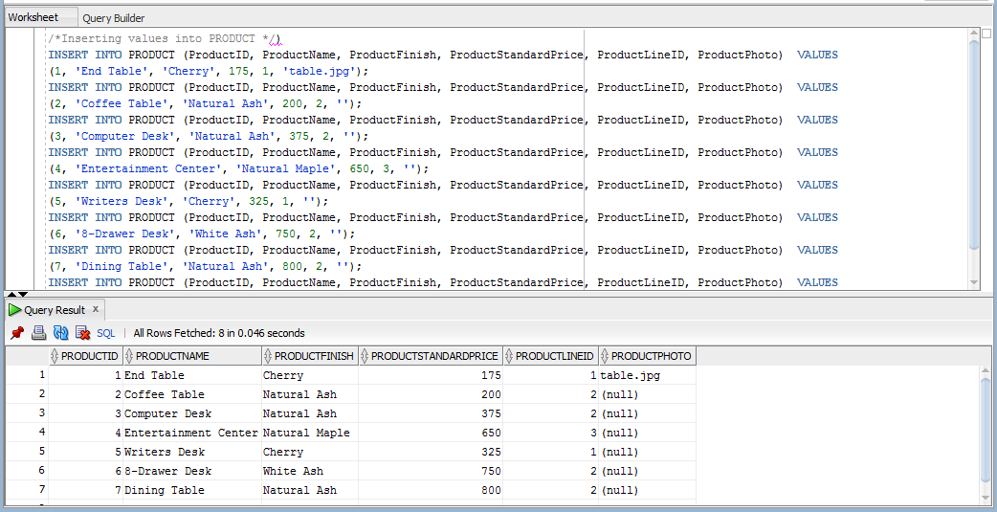

ProductLine
ProductLineID, ProductLineName
1, 'Cherry Tree'
2, 'Scandinavia'
3, 'Country Look'

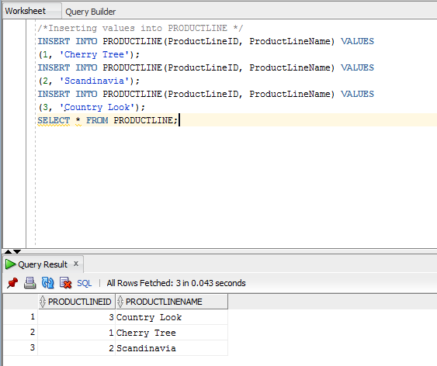

Order
OrderID, OrderDate, CustomerID
1001, '21/Aug/16', 1
1002, '21/Jul/16', 8
1003, '22/ Aug/16', 15
1004, '22/Oct/16', 5
1005, '24/Jul/16', 3
1006, '24/Oct/16', 2
1007, '27/ Aug/16', 5
1008, '30/Oct/16', 12
1009, '05/Nov/16', 4
1010, '05/Nov/16', 1
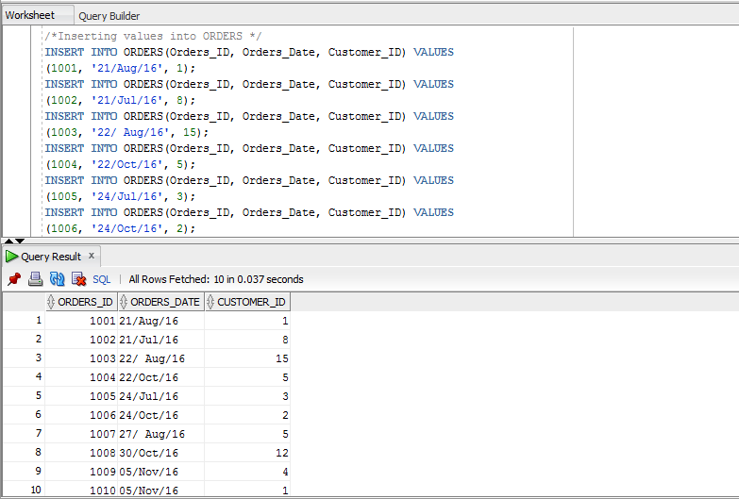
OrderLine
OrderID, ProductID, OrderedQuantity, SalePrice
1001, 1, 2
1001, 2, 2
1001, 4, 1
1002, 3, 5
1003, 3, 3
1004, 6, 2
1004, 8, 2
1005, 4, 4
1006, 4, 1
1006, 5, 2
1006, 7, 2
1007, 1, 3
1007, 2, 2
1008, 3, 3
1008, 8, 3
1009, 4, 2
1009, 7, 3
1010, 8, 10
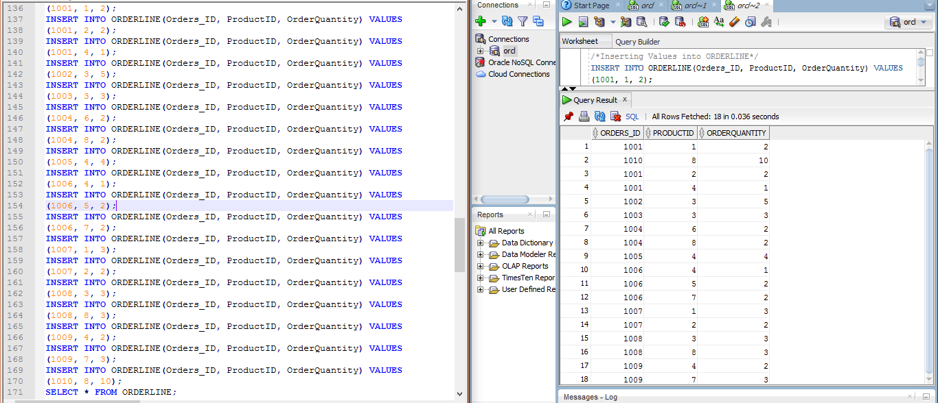

PriceUpdate
PriceUpdateID, DateChanged, OldPrice, NewPrice

B. (65 points) The Client wishes that you create the SQL code for the following queries (please make sure you SQL COMMENT each query and produce the screenshots for SQL COMMENT, SQL COMMAND, and SQL OUTPUT each, to be placed in Project2.doc):

- (4 points)
Which products have a standard price of less than $ 275?

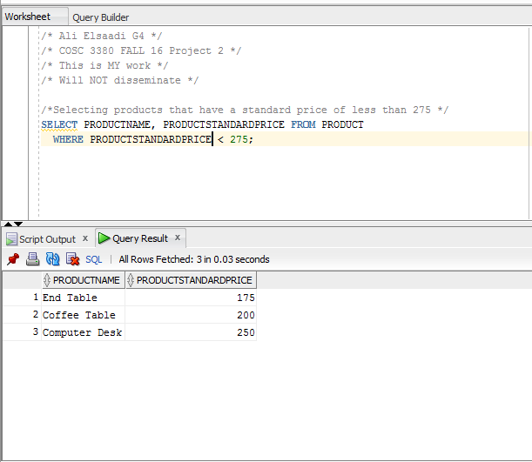
- (4 points)
List the unit price, product name, and product ID for all products in the Product table.

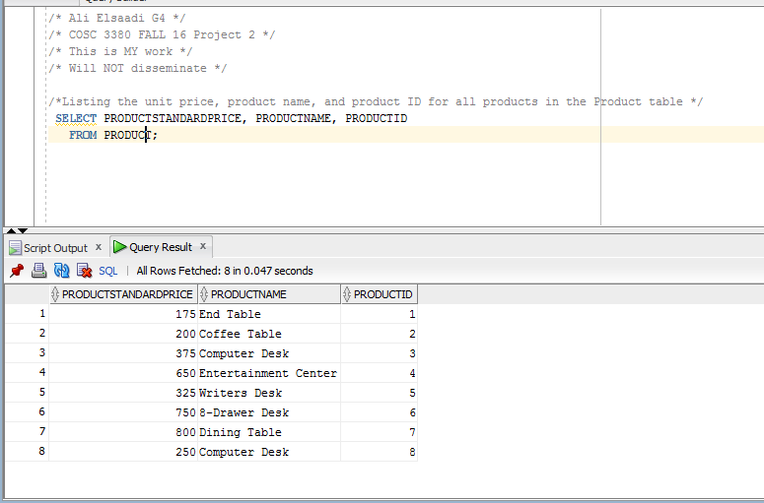
- (4 points)
What is the average standard price for all products in inventory?

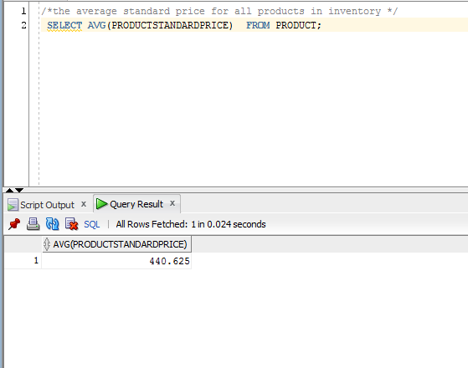
- (4 points)
How many different items were ordered on order number 1004?

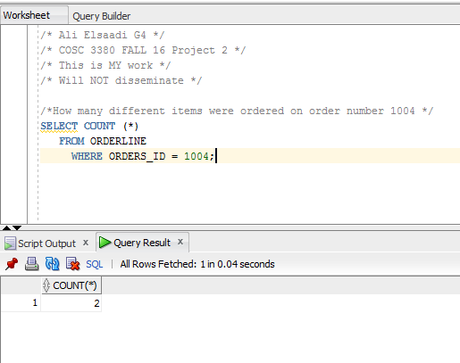

- (4 points)
Which orders have been placed since 10/ 24/ 2010?

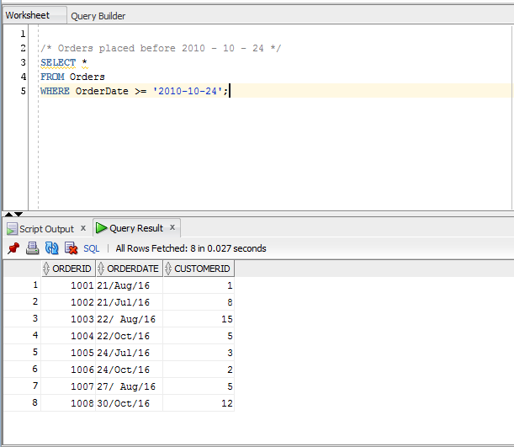
- (5 points)
What furniture does COSC3380 carry that isn’t made of cherry?

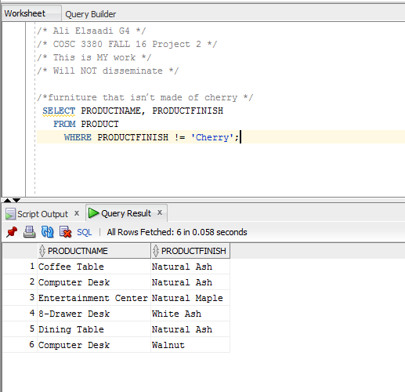

- (5 points)
List product name, finish, and standard price for all desks and all tables that cost more than $ 300 in the Product table.

(Screenshot of the SQL COMMAND, SQL STATEMENT, and SQL OUTPUT need to be captured in Project2.doc.)

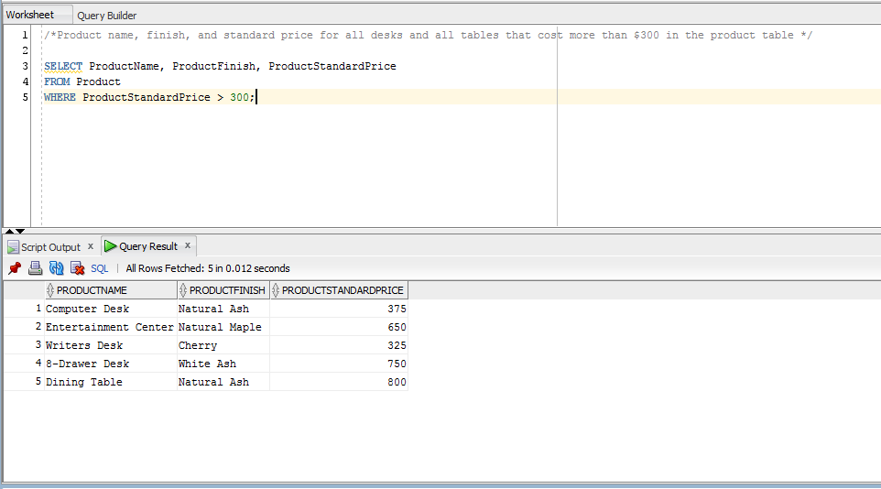
- (5 points)
Which products in the Product table have a standard price between $ 200 and $ 300?

(Screenshot of the SQL COMMAND, SQL STATEMENT, and SQL OUTPUT need to be captured in Project2.doc.)

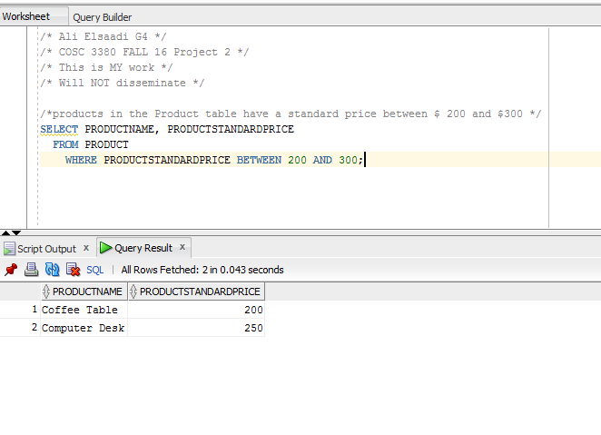

- (5 points)
List customer, city, and state for all customers in the Customer table whose address is Florida, Texas, California, or Hawaii. List the customers alphabetically by state and alphabetically by customer within each state.

(Screenshot of the SQL COMMAND, SQL STATEMENT, and SQL OUTPUT need to be captured in Project2.doc.)
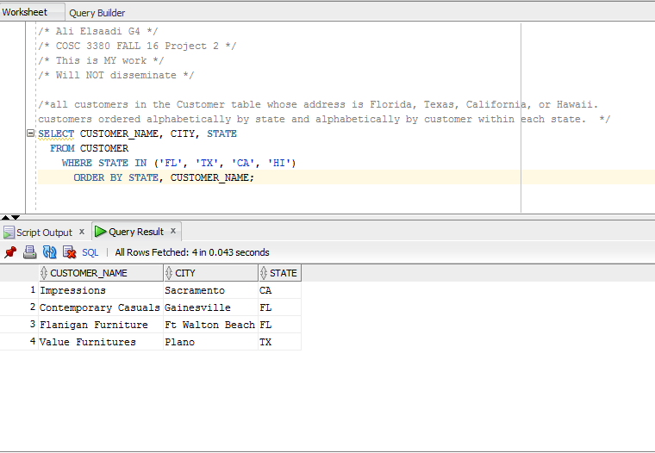

- (5 points)
Count the number of customers with addresses in each state to which we ship.

(Screenshot of the SQL COMMAND, SQL STATEMENT, and SQL OUTPUT need to be captured in Project2.doc.)
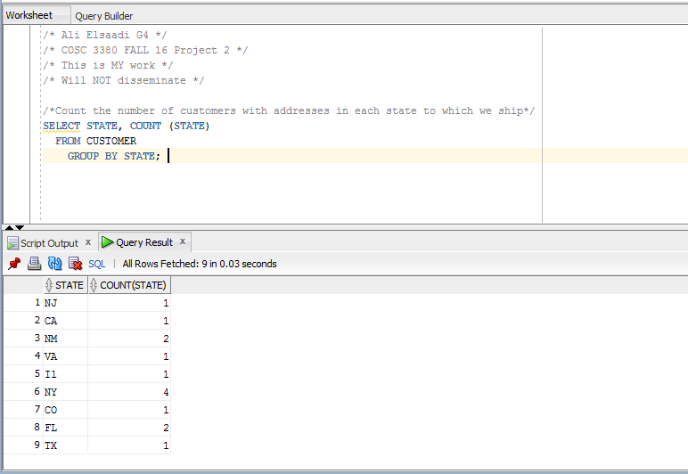

- (5 points)
Count the number of customers with addresses in each city to which we ship. List the cities by state.

(Screenshot of the SQL COMMAND, SQL STATEMENT, and SQL OUTPUT need to be captured in Project2.doc.)
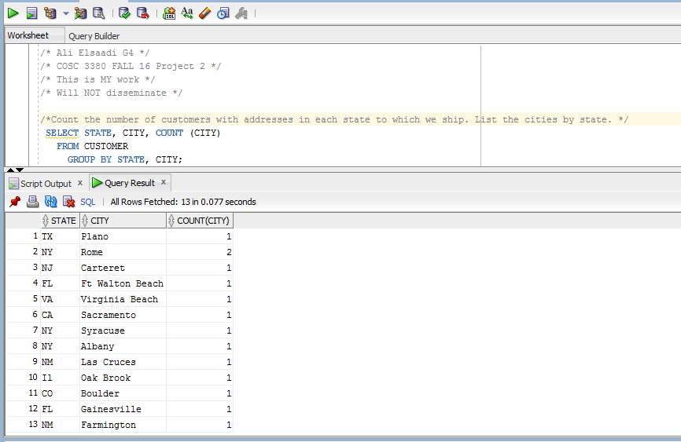

- (5 points)
Find only states with more than one customer.

(Screenshot of the SQL COMMAND, SQL STATEMENT, and SQL OUTPUT need to be captured in Project2.doc.)

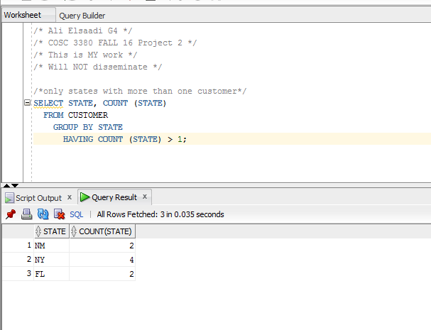

- (5 points)
List, in alphabetical order, the product finish and the average standard price for each finish for selected finishes having an average standard price less than 750.

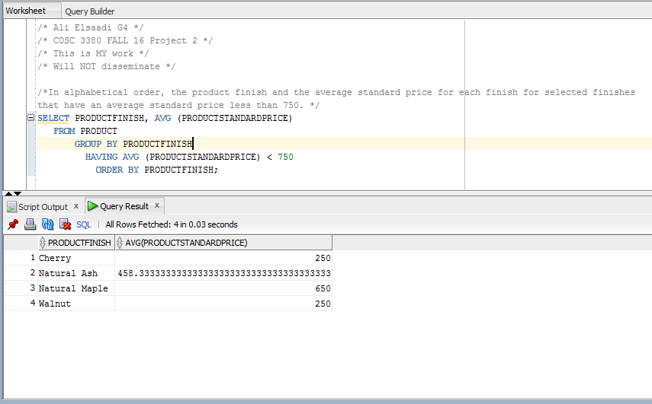

- (5 points)
What is the total value of orders placed for each furniture product?

